Ray2Z Catering Menu
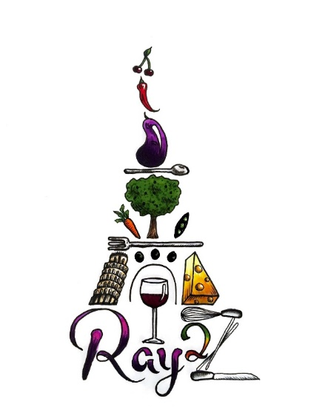
Small platters serve 5-10/Large serves 10-20
Vegetable Platter $24/$50
-seasonal fresh cut veggies
Add House Ranch $5 or House Made Hummus $10
Fruit Platter $30/$60
-seasonal fresh cut fruit and berries
Add Honey Yogurt Dip $5/$10
Full Size Sandwiches (Sm- 5 each, Lg- 10 each)
BLT $40/$85
- Thick cut applewood smoked bacon, crisp iceberg lettuce and roma tomatoes on ciabatta rolls with mayo
Turkey Brie $60/$120
- Fresh cut turkey breast, sliced brie cheese, arugula and cranberry mayo on whole wheat bread
Cranberry Chicken Salad on Croissant $45/$90
- Oven roasted herb chicken breast tossed with red onion, celery, mayo, and cranberries
Caprese $35/$70 (vegetarian)
- Fresh mozzarella stacked with Roma tomatoes and fresh basil with balsamic glaze

Wraps
Mediterranean $40/$80
- Spinach, kalamata olives, red onion, cucumber, feta cheese and hummus
Southwest $45/$85
- Romaine, tomatoes, red onion, black beans, corn, quinoa and red pepper hummus

Salads
Small platter feeds 4-6, Large feeds 8-12
Strawberry $25/$50 – Spinach, strawberries, carrots, red onions, quinoa, feta cheese, almonds, cider vinaigrette
Mediterranean $30/$60- Spinach, kalamata olives, red onion, cucumber, chickpeas, oregano vinaigrette
Southwest $35/$70- Romaine, tomato, red onion, black beans, corn, quinoa, bell pepper, cilantro lime dressing

Appetizers
(Prices are per dozen)
Tea Sandwiches
Classic Cucumber & Cream Cheese on White Bread $10
Egg Salad on Wheat Bread $12
Ham & Swiss on Rye Bread $15
Turkey & Brie with Cranberry Mayo on Wheat Bread $25

Small Bites
(Prices are per dozen)
Caprese Skewers $30
- Fresh tomatoes, basil and mozzarella drizzled with balsamic glaze
Grilled Peach Crostini $35
- Sliced peaches, fresh mozzarella cheese and fresh basil on a crispy garlic crostini drizzled with balsamic glaze
Crispy Polenta Cakes with Tomato Jam $30
- Creamy parmesan polenta topped with tomato jam and greens
Sweet Chili Shrimp Skewers $35
- Plump cooked shrimp glazed with our house made sweet chili sauce
Sweet Gorgonzola Polenta $25
- Polenta cakes topped with crumbled gorgonzola, candied walnuts and balsamic glaze
Antipasto Kebab $30
- Cherry tomatoes, kalamata olives, artichoke hearts, fresh mozzarella cheese, salami and basil marinated in our house made Italian dressing
Prosciutto Wrapped Peaches $35
- Juicy fresh peaches wrapped in prosciutto
Bruschetta $15
- Garlic rubbed crostini topped with tomatoes, garlic, basil and balsamic vinegar

Goat Cheese Tapenade Crostini $18
- Crispy garlic crostini topped with whipped goat cheese and our house made tapenade
Cuban Skewers $15
- Ham, Swiss cheese, whole grain mustard and cornichon pickles
Spinach & Artichoke Stuffed Mushrooms $25
- Spinach, artichoke hearts and mozzarella cheese topped with crispy panko breadcrumbs
Watermelon Feta Skewers $20
- Fresh cubed watermelon topped with feta crumbles and fresh mint

Baked Cranberry Brie Bites $30
- Brie and cranberry jam baked in puff pastry cups

